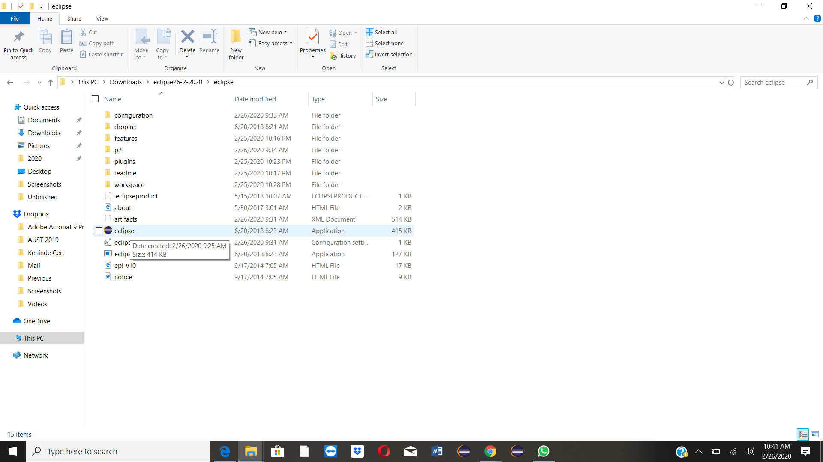

**Step 1. Double Click on the Eclipse application**

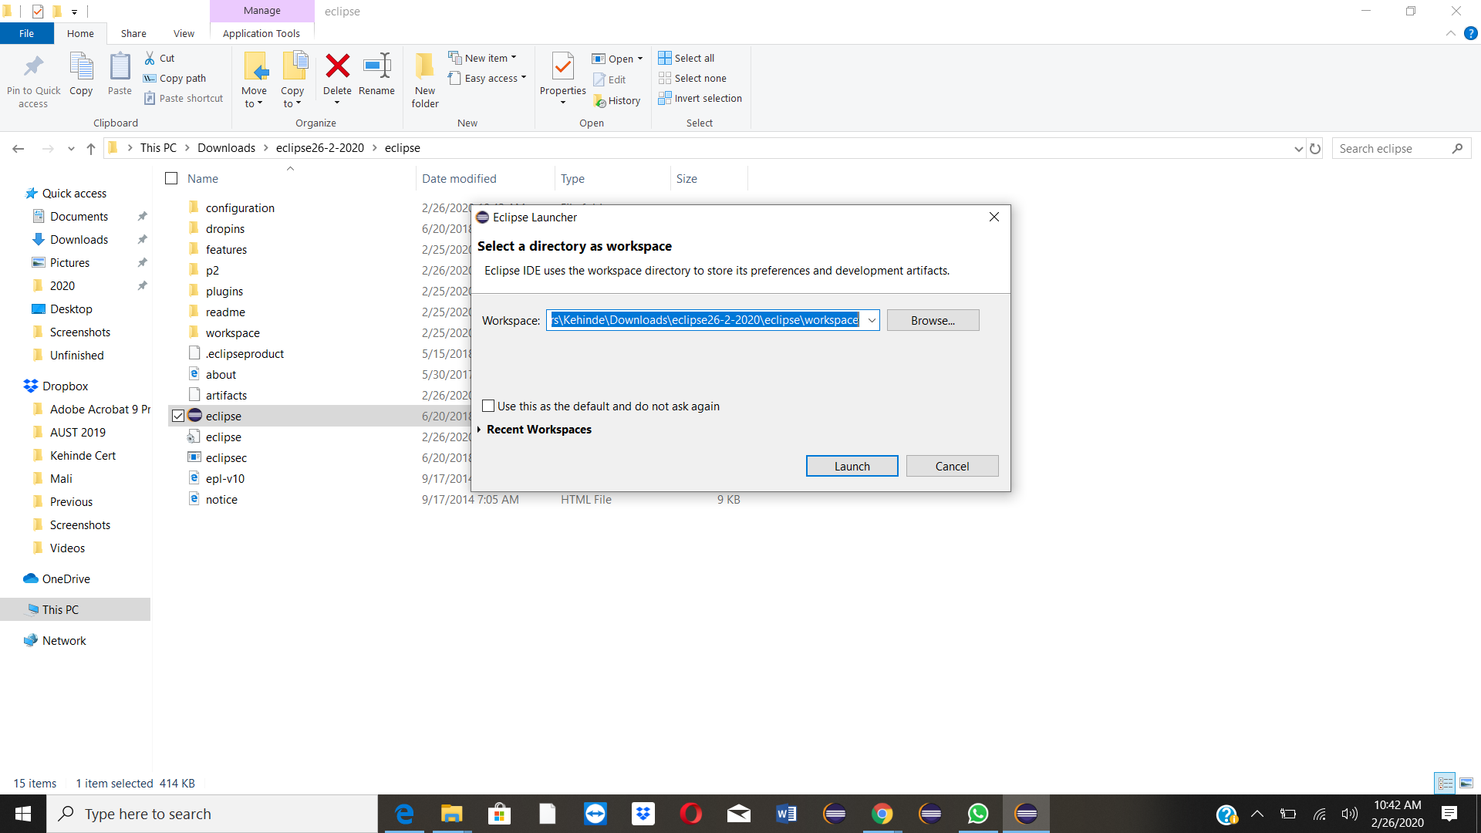

**Step 2. Browse to the location of the workspace and lunch**

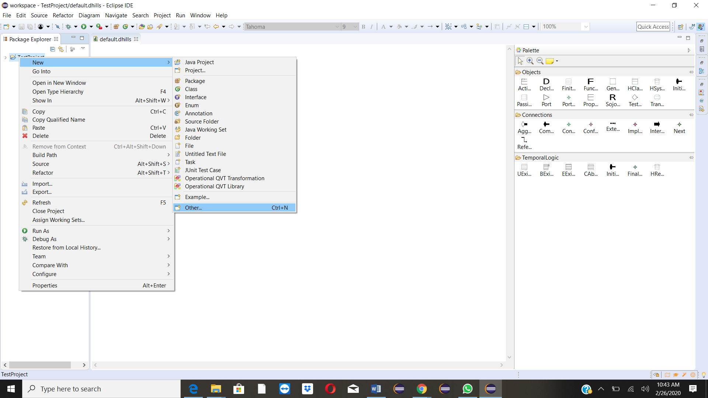

**Step 3. Right click on the Project > New > Others**

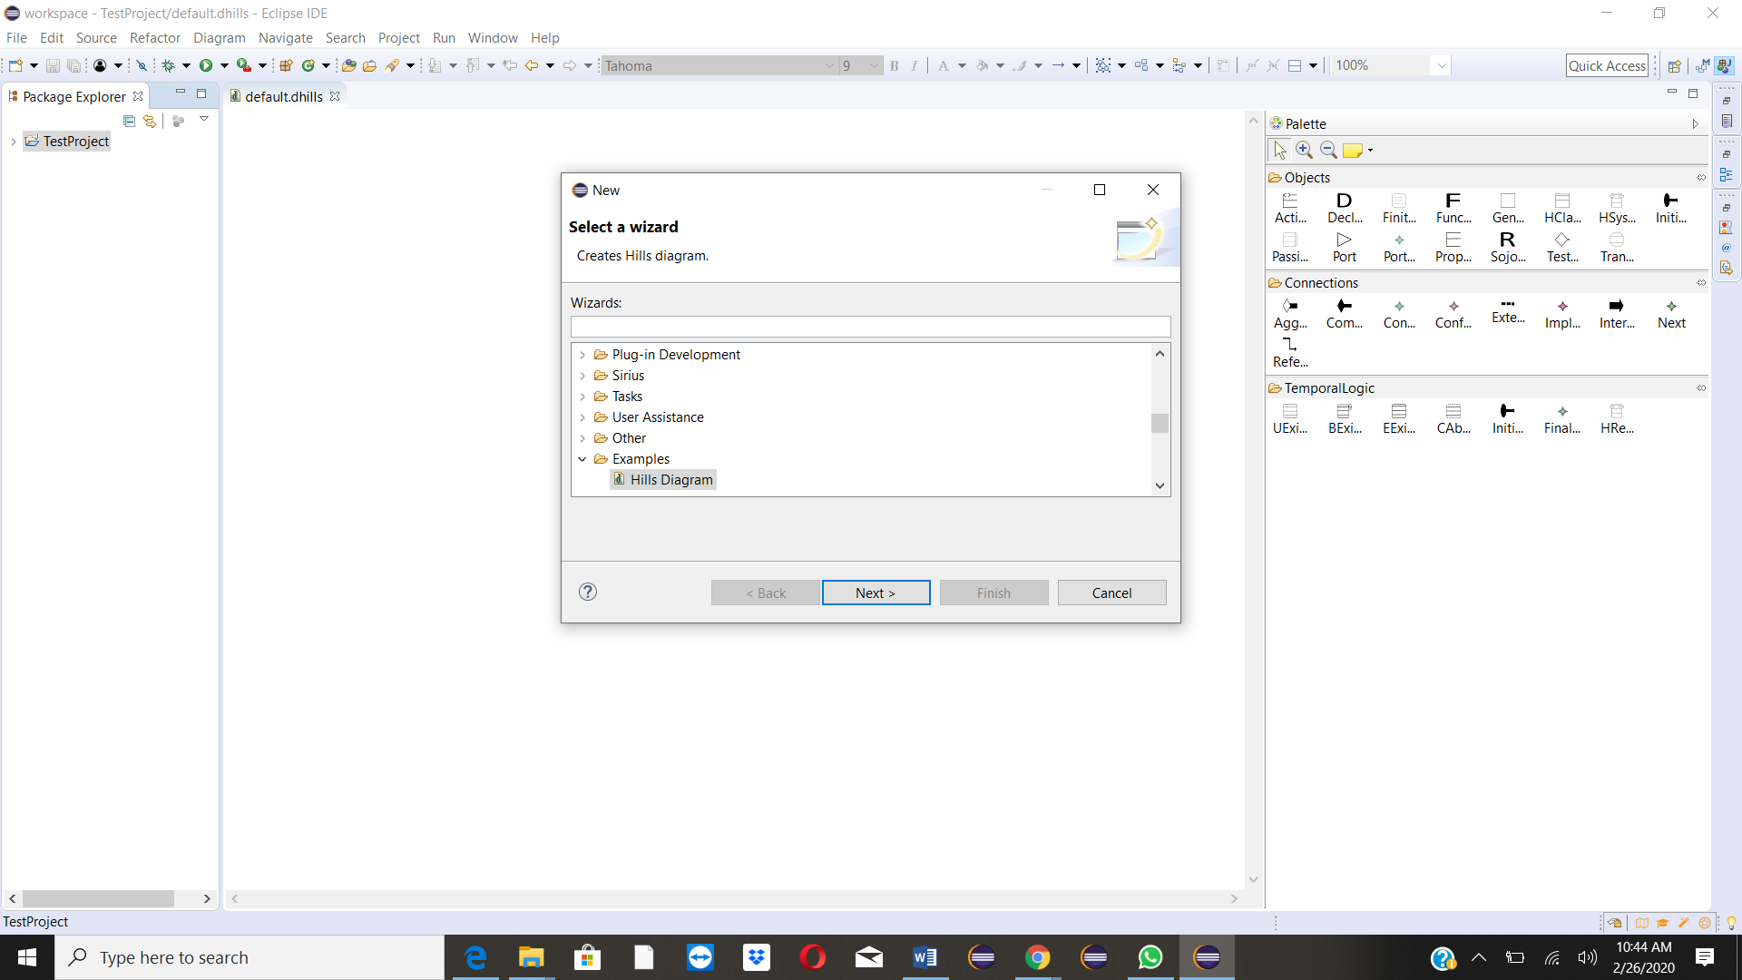

**Step 4. Go to Examples > HiLLS Diagram > Next**

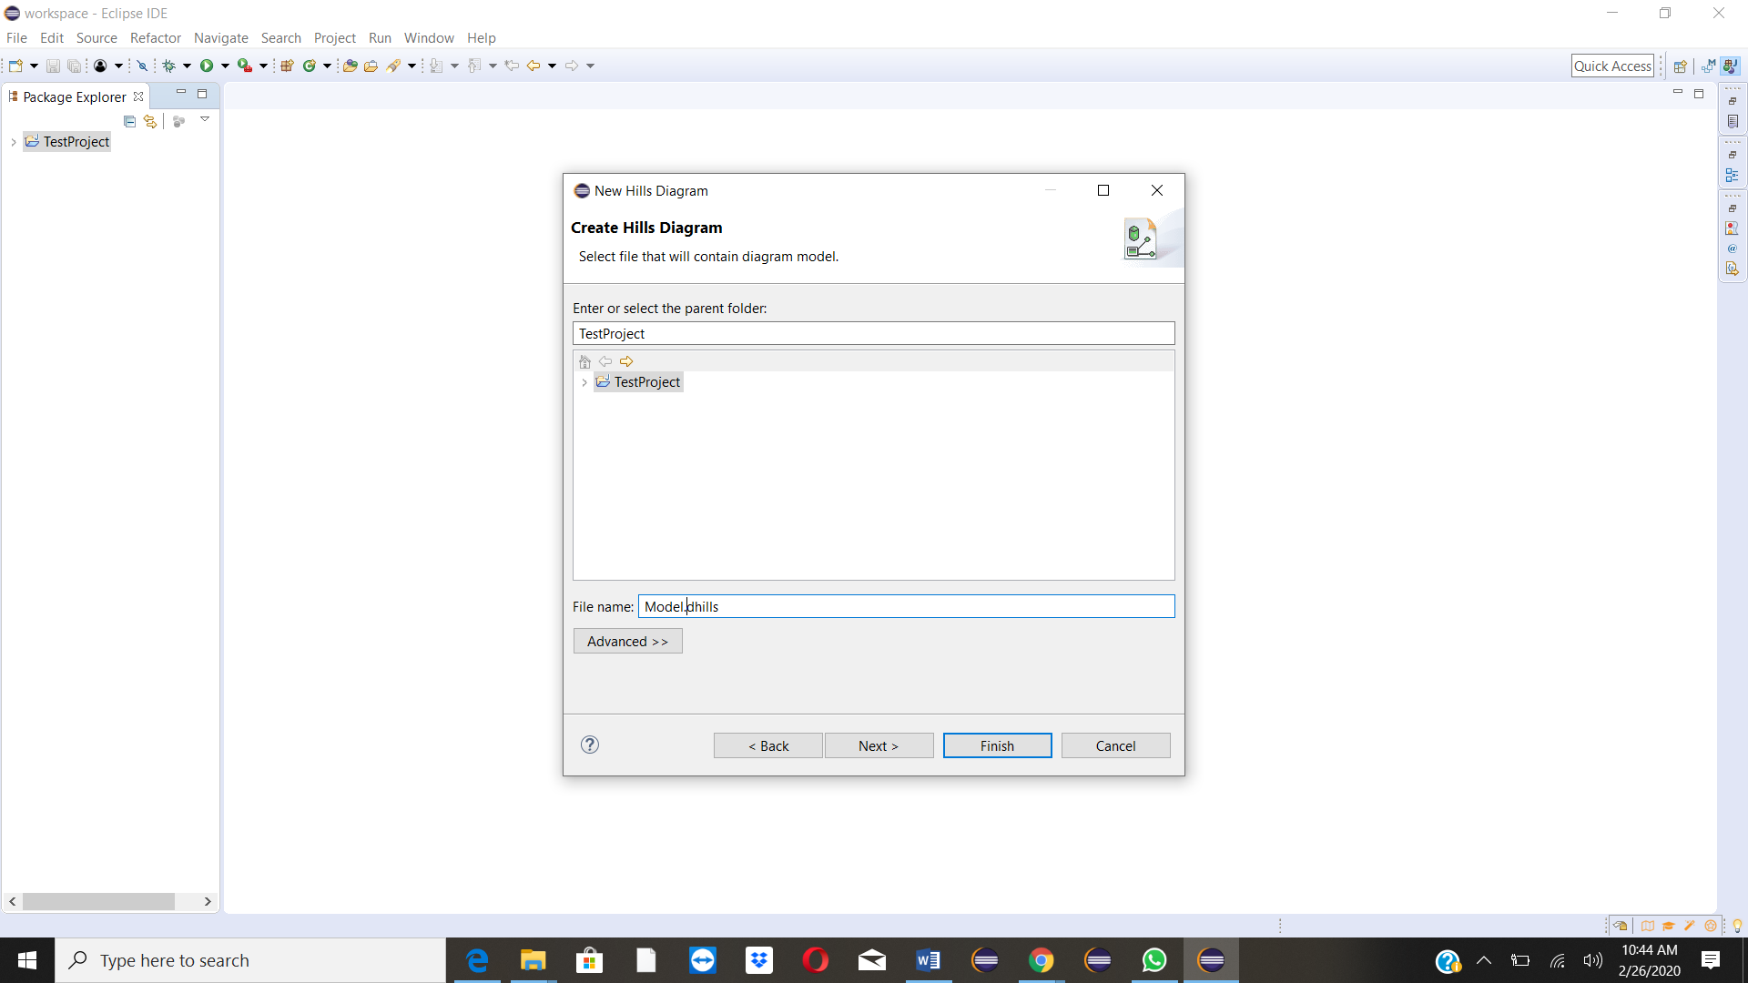

**Step 5. Give your model a name > finish**

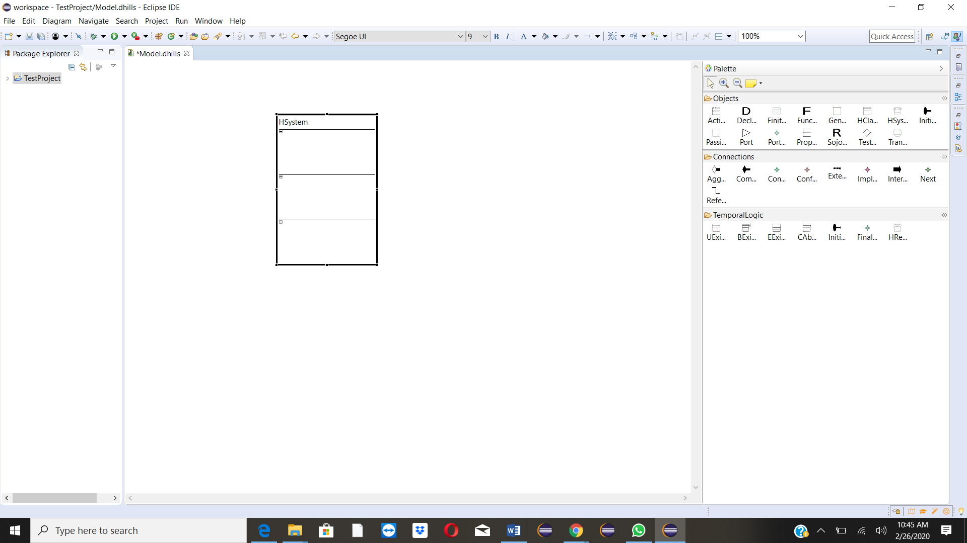

**Step 6. Start drawing your HiLLS Model, starting with the HSystem**